**Data Team Coding Challenge**

Question 2

1. Which month has the highest sales? Is there any seasonality effect?

*Queried from Qn 2 Part 1.sql*

|  |  |  |  |  |  |
| --- | --- | --- | --- | --- | --- |
| months | 2014 | 2015 | 2016 | 2017 | Total in Months |
| 1 | 14,236.90 | 18,174.08 | 18,542.49 | 43,971.37 | 94,924.84 |
| 2 | 4,519.89 | 11,951.41 | 22,978.82 | 20,301.13 | 59,751.25 |
| 3 | 55,691.01 | 38,726.25 | 51,715.88 | 58,872.35 | 205,005.49 |
| 4 | 28,295.35 | 34,195.21 | 38,750.04 | 36,521.54 | 137,762.13 |
| 5 | 23,648.29 | 30,131.69 | 56,987.73 | 44,261.11 | 155,028.81 |
| 6 | 34,595.13 | 24,797.29 | 40,344.53 | 52,981.73 | 152,718.68 |
| 7 | 33,946.39 | 28,765.33 | 39,261.96 | 45,264.42 | 147,238.10 |
| 8 | 27,909.47 | 36,898.33 | 31,115.37 | 63,120.89 | 159,044.06 |
| 9 | 81,777.35 | 64,595.92 | 73,410.02 | 87,866.65 | 307,649.95 |
| 10 | 31,453.39 | 31,404.92 | 59,687.75 | 77,776.92 | 200,322.98 |
| 11 | 78,628.72 | 75,972.56 | 79,411.97 | 118,447.83 | 352,461.07 |
| 12 | 69,545.62 | 74,919.52 | 96,999.04 | 83,829.32 | 325,293.50 |

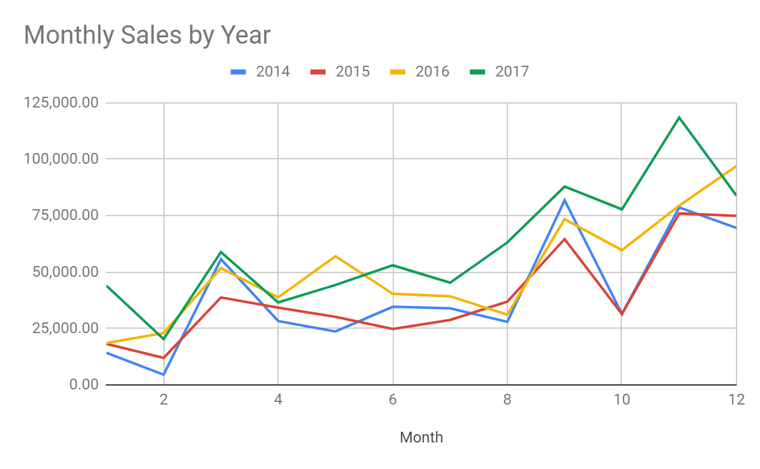

**Answer:**

Based on the above table on total 4 years of data, November was the month with the highest sales.

Based on the chart above, we can see that the trend generally increased over 1 year, regardless any year. Hence it shows that the consumers prefer to purchase or spend during the end of the year.

That could also due to promotions or festive seasons that moved consumers in purchase in bigger quantities.

Question 2

1. Which product is the recent best seller?

*Queried from Qn 2 Part 2.sql (Top 5 from 2017)*

|  |  |  |  |  |  |
| --- | --- | --- | --- | --- | --- |
| productname | 2014 | 2015 | 2016 | 2017 | Total in Months |
| Staples | 52 | 39 | 56 | 68 | 215 |
| Easy-staple paper | 22 | 39 | 31 | 58 | 150 |
| Staples in misc. colors | 20 | 6 | 8 | 52 | 86 |
| Staple envelope | 54 | 43 | 34 | 39 | 170 |
| Storex Dura Pro Binders | 7 | 15 | 12 | 37 | 71 |

*Highlighted shows the best seller in the year

**Answer:**

On the recent years (since 2016), Staples is the best sellers.

Few reasons that staples top the selling chart:

1. Staples could be sold as individual product or as a bundle promotion with other stationaries, which allows staples to be an essential product.
2. Staples has different product models which sells at different pricings.

Question 2

1. Is there any group of products which are often bought together?

**Answer:**

There is no clear group of products which were often bought together. Based on the queried results, there are 65 pairs of products that are bought 2 times, while the rest of the pairs were once. In such case, it will be hard to distinguish a certain pattern from it.

Alternatively a more distinct segregation can help with identifying the group of products purchased by the type of stationaries bought. For instance Printer, Cartridge, Pens, etc.

Question 2

1. Is there any other insight you can get to help to improve sales number?

**Answer:**

1. Based on the data, we can further analyse the data if there were any promotions going on. That would help us to determine the cost vs revenue.
2. We could also look at different festive seasons towards the sales.
3. We could also look at the regular clients and their recent purchases such that when new released products could entice clients to check them out.
4. Understand the client base in terms on their industries (if its entity) or retail clients. That could help to identify the right product for the right clients.

Question 2

1. Based on the data we have, what kind of BI dashboards you would build in order to help the sales team monitoring the performance?

**Answer:**

1. Monthly Revenue
   1. Split by sales team
   2. Split by client base since when (shows new acquisitions revenue vs existing)
   3. Actual vs Target
2. Monthly Volume
   1. Split by sales team
   2. Split by client base since when (shows new acquisitions volume vs existing)
   3. Actual vs Target
3. Promotion Targeted products and their sales numbers
4. Number of clients reached out by sales team
5. Any referred clients by existing clients
6. Online (if any) such as website, social media, etc flows
7. Competitor dashboard
   1. Shows the current promotions (if any)
   2. Any product price significant lower
8. Feedback and/or Complaints
9. Top Sales Chart
10. Deliverables
    1. Suppliers towards Company
    2. Company towards Clients (% of meeting requirements)